1: Analysis Framework
Konduri, T., & Li, Q. (2024, July 17). Forecasting macroeconomic variables: A systematic comparison of machine learning methods. University of Notre Dame; Indiana Legislative Services Agency Konduri_JMP.pdf.
- The framework that we are going to replicate and build upon was established by Konduri and Li 2024.
- Uses FRED data and the following table of methods to predict industrial production, employment, consumer price index, and the S&P 500.
- Finds that traditional methods outperform machine learning techniques for real variables like industrial production and employment. The ML methods underperformed traditional models for nominal variables like the CPI and S&P.

Questions:
- They use a Pseudo out-of-sample design to evaluate the performance. What are the pros and cons of this approach and should we adopt it ourselves?
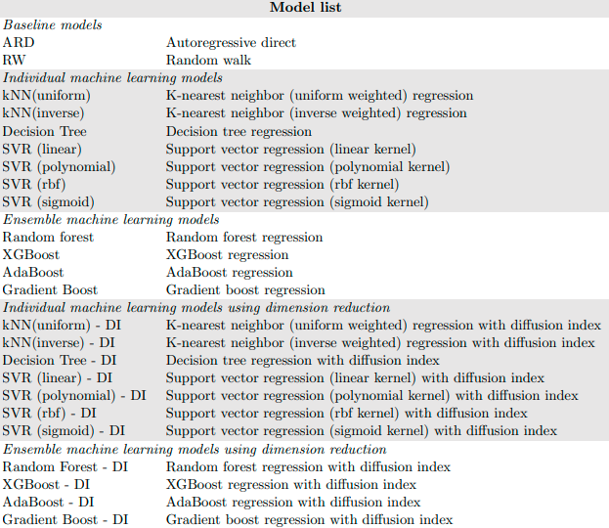

2: Quantum Reservoir Computing:

Chen, S. Y.-C., Fry, D., Deshmukh, A., Rastunkov, V., & Stefanski, C. (2022). Reservoir computing via quantum recurrent neural networks. arXiv. https://doi.org/10.48550/arXiv.2211.02612

This is a great paper that introduces parameterized quantum circuits, and quantum reservoir models
We will recreate the QRNN-RC (simplest) model in the paper, as see how it compares to the classical models in terms of fit, generalization, and computational cost. Figure 3. Is the key figure, showing the architecture of the quantum reservoir we will be employing:
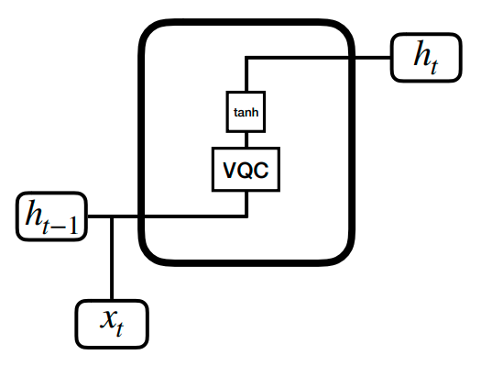
- In a standard Recurrent Neural Network reservoir (also called an echo state network) this is the architecture for one time step.
- The vector h carries information about previous time steps.
- The vector x is the feature vector for one particular time step. The VQC box is a Variational Quantum Circuit.
- A VQC is the part that we actually run on a quantum computer, in certain contexts it is also called a Quantum Neural Network.
- We train a GLM on the final vector h after t time steps

3. Signature Kernels with Quantum Features

Moody’s. Recession Prediction Using Quantum Computing. Moody’s,
https://www.moodys.com/web/en/us/about/what-we-do/quantum-computing/recession-prediction.html. Accessed 6 Apr. 2026.

- Introduces a signature kernel with quantum features
- Uses a classification-based signature kernel to predict months with looming economic recessions

4. Additional resources on Quantum Computing:
- Introduction to Quantum Computing- quantum Computing fundamentals | IBM Quantum Learning
- Python library we will use to interface with quantum computers - Introduction to Qiskit | IBM Quantum Documentation

5. Additional resources:
- This paper introduces a different category of quantum reservoir that uses the time evolution of a random hamiltonian instead of a VQC. Most importantly, it outlines the argument for the non-linearity and benefits of using a quantum reservoir -untitled
- This paper uses quantum enhanced features for a support vector machine, and clearly outlines the circuit they use to generate said features- Supervised learning with quantum-enhanced feature spaces | Nature
- This paper uses noise (i.e. physical error) in the quantum processor as a feature instead of a bug, and argues that the decoherence is necessary to mimic the fading memory of a properly tuned quantum reservoir - Optimizing quantum noise-induced reservoir computing for nonlinear and chaotic time series prediction | Scientific Reports
- This is a foundational paper on using quantum features in machine learning. Outlines the inspiration and fundamental concepts - [1803.07128] Quantum machine learning in feature Hilbert spaces
- Classical reservoir computing based on recurrent neural networks -2006.07310
- Classical time series predictions with signature kernels -The Signature Kernel is the solution of a Goursat PDE
- This paper uses a more sophisticated quantum reservoir that is based on LSTM instead of a vanilla RNN - Scopus - Document Details
- This is an announcement from a startup that offers product that is similar to our project for classification and forecasting tasks - Kipu Quantum’s Rimay Now Generally Available, Delivering
- This is a controversial paper from HSBC that argued a financial benefit from using quantum features in a trading algorithm. The paper saw criticism because they once again observed that the algorithm worked better with noisy data from a real processor than simulated perfect data. This means that their model was likely overfit, and that the noise served as an uncontrollable regularization method - Enhanced fill probability estimates in institutional algorithmic bond trading using statistical learning algorithms with quantum computers
- [2604.06075] Late Breaking Results: Hardware-Efficient Quantum Reservoir Computing via Quantized Readout
- Chebychev encoding - Exponential data encoding for quantum supervised learning | Phys. Rev. A
- Different Reservoirs closer to the canonical QRNN - Time-series quantum reservoir computing with weak and projective measurements | npj Quantum Information

